MUT:1399311
CLEM: FPh710E

Operational State is Active
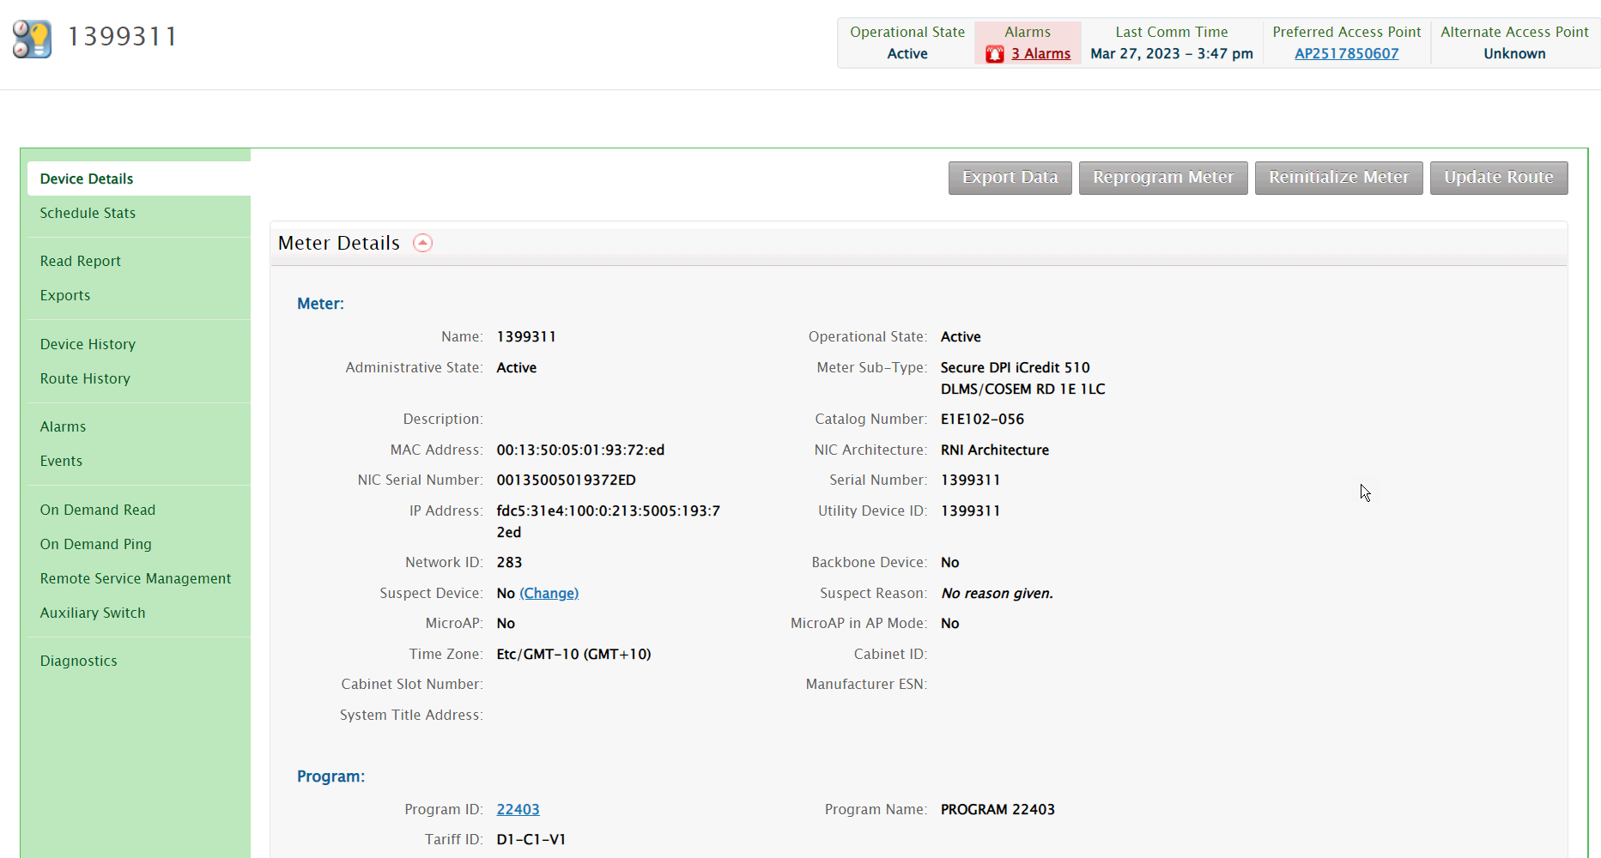

Auto-disconnect is Enabled in Meter tariff
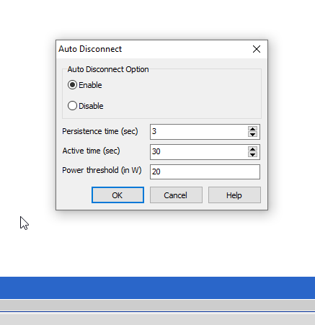

Switch is disconnected via UIQ
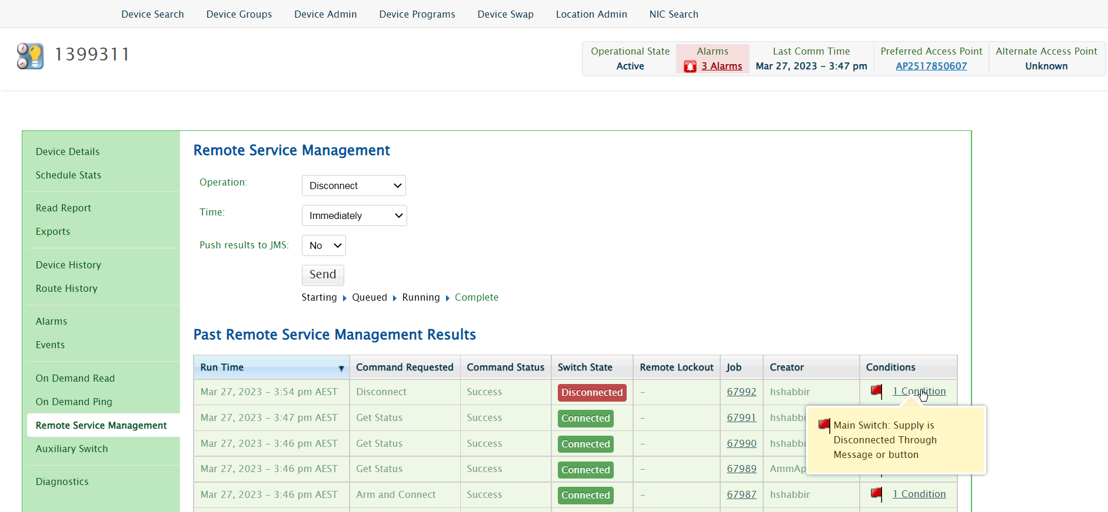

Auto-disconnect settings disabled via arbitrary command
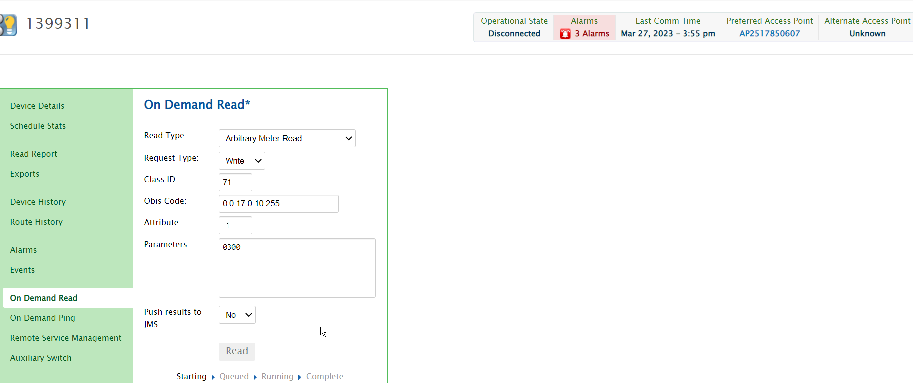

Response for Arbitrary write (to Disabled Auto-disconnect setting)
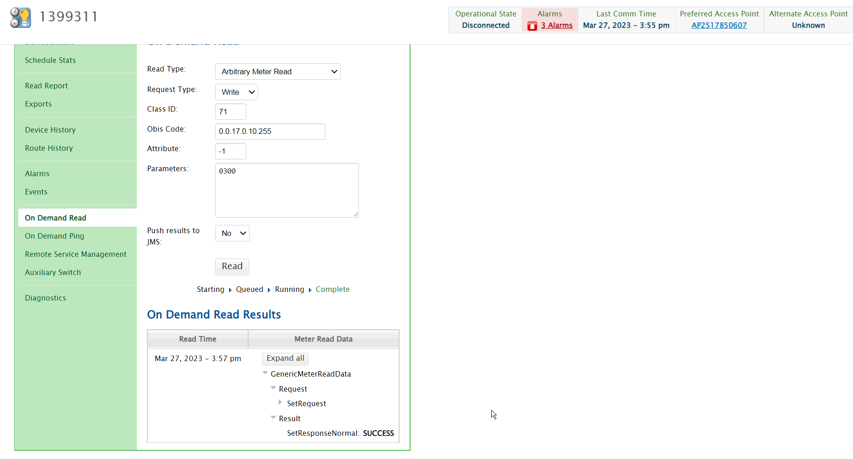

Auto-disconnect settings in the meter (after write command)
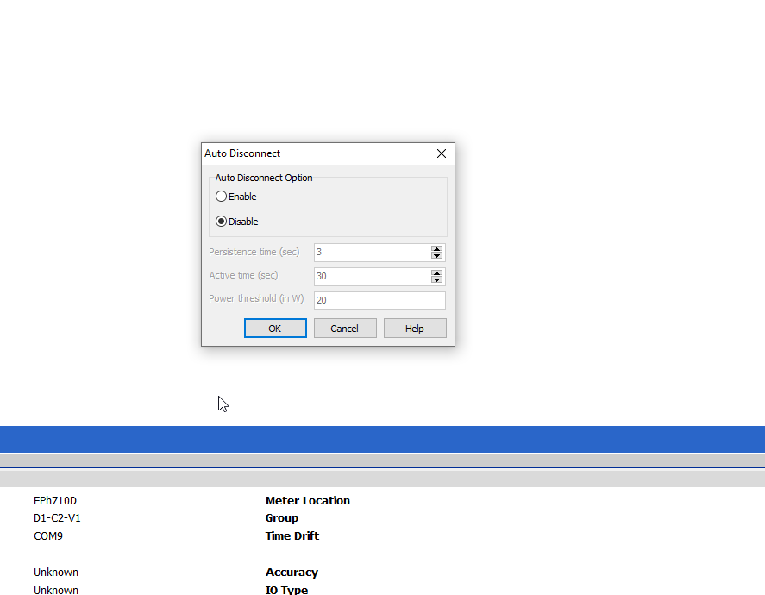

Connect command issued via UIQ with a load connected (greater than auto-disconnect threshold) to it.
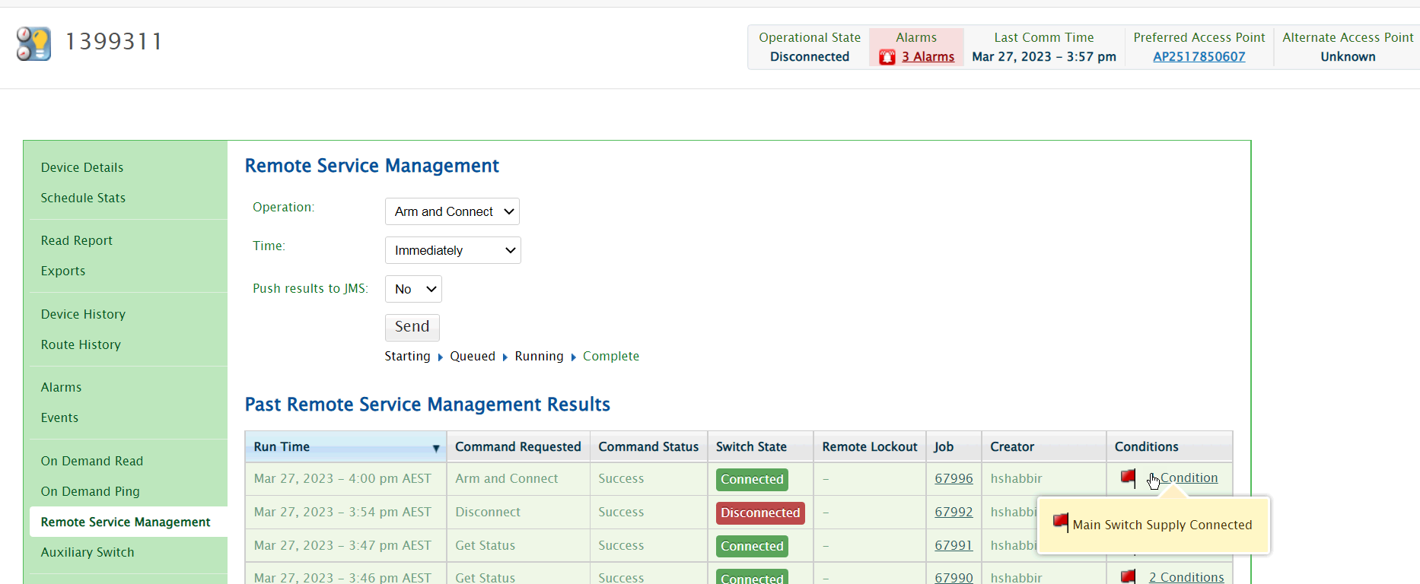

Waited for 30 secs (active time for Auto-disconnect). Meter did not got disconnected due to Auto-disconnect.

Auto-disconnect settings Enabled via arbitrary command
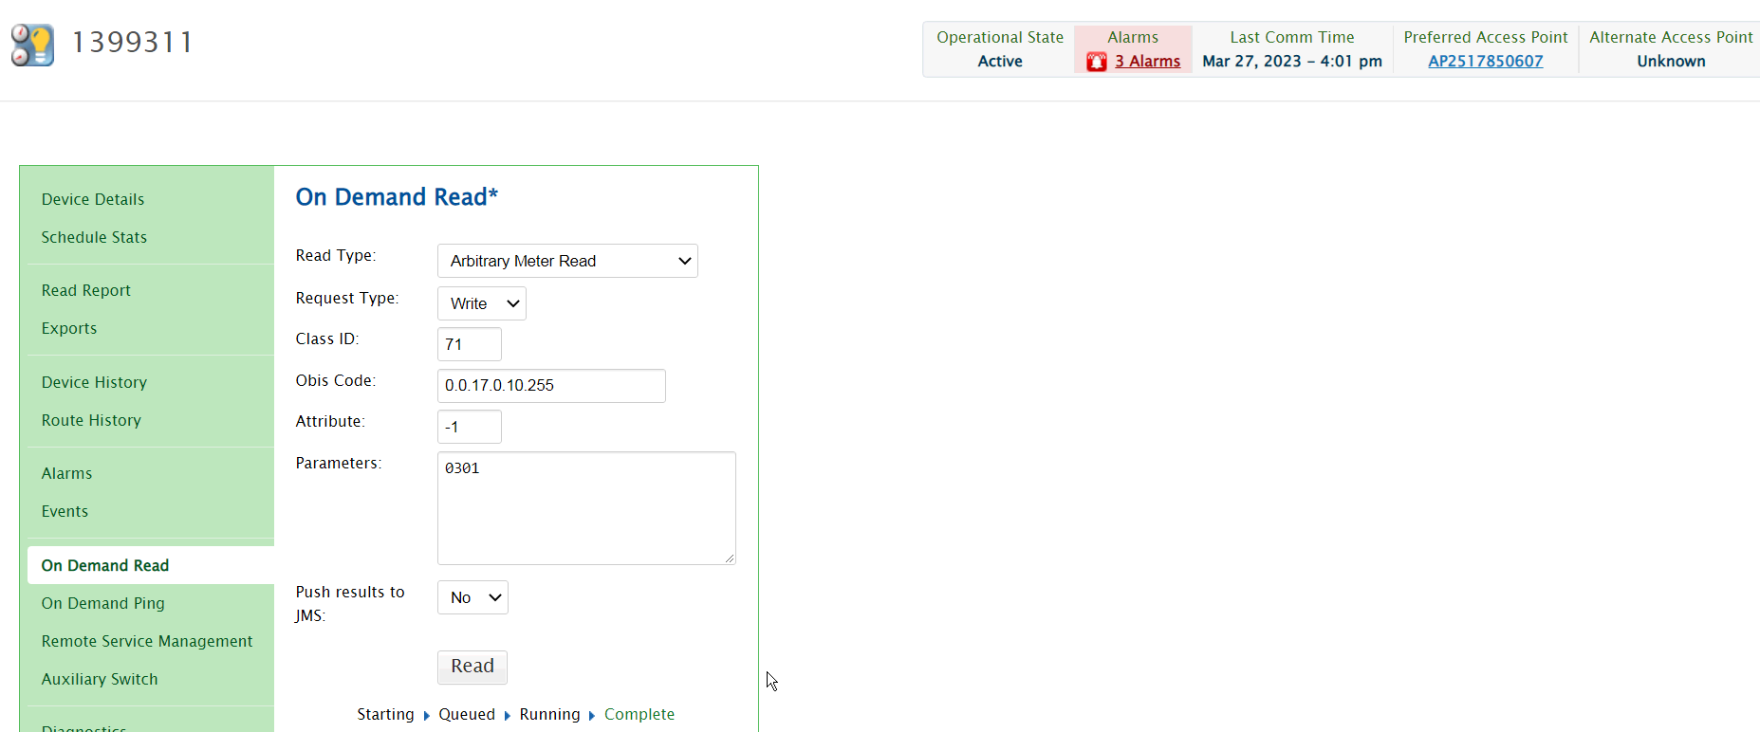

Response for Arbitrary write (to Disabled Auto-disconnect setting)
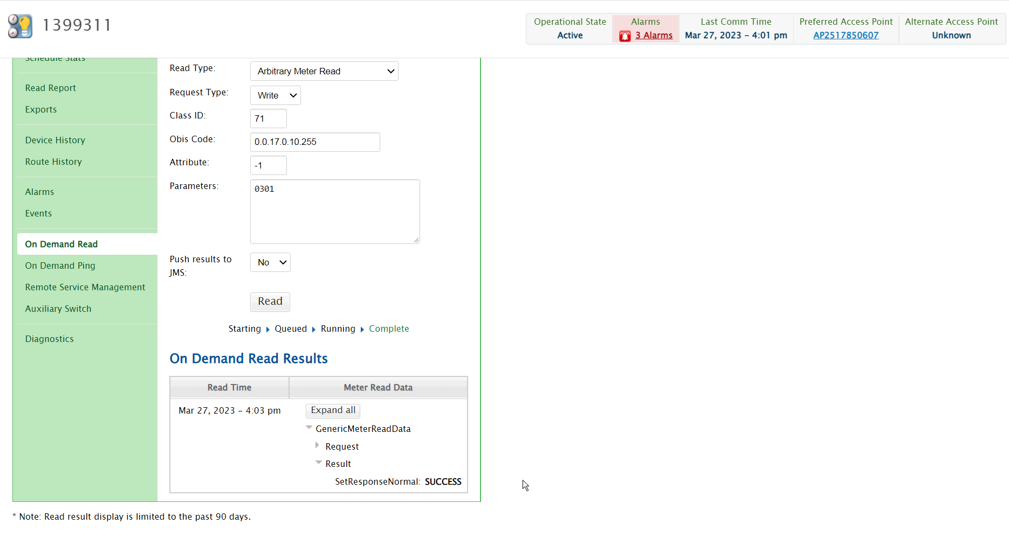

Auto-disconnect settings read back again after write command

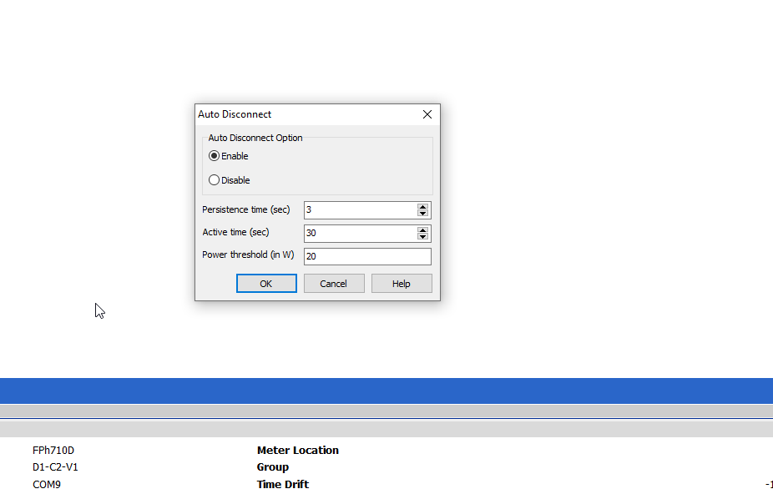

Test-Pas

